**MIS - UNIT 1**

**Management Information System( MIS): Concept & definition**

Management Information Systems (MIS), referred to as Information Management and Systems, is the discipline covering the application of people, technologies, and procedures collectively called information systems, to solving business problems.

***“'MIS' is a planned system of collecting, storing and disseminating data in the form of information needed to carry out the functions of management.”***

Academically, the term is commonly used to refer to the group of information management methods tied to the automation or support of human decision making, e.g. Decision Support Systems, Expert Systems, and Executive Information Systems.

**Management** : Management is art of getting things done through and with the people in formally organized groups. The basic functions performed by a manager in an organization are: Planning, controlling, staffing, organizing, and directing.

**Information** : Information is considered as valuable component of an organization. Information is data that is processed and is presented in a form which assists decision maker.

**System :** A system is defined as a set of elements which are joined together to achieve a common objective. The elements are interrelated and interdependent. Thus every system is said to be composed of subsystems. A system has one or multiple inputs, these inputs are processed through a transformation process to convert these input( s) to output.

**MIS DEFINITION:**

The Management Information System (MIS) is a concept of the last decade or two. It has been understood and described in a number ways. It is also known as the Information System, the Information and Decision System, the Computer- based information System.

The MIS has more than one definition, some of which are give below:

1. The MIS is defined as a system which provides information support for decision making in the organization.

2. The MIS is defined as an integrated system of man and machine for providing the information to support the operations, the management and the decision making function in the organization.

3. The MIS is defined as a system based on the database of the organization evolved for the purpose of providing information to the people in the organization.

4. The MIS is defined as a Computer based Information System.

Thought there are a number of definitions, all of them converge on one single point, i.e., the MIS is a system to support the decision making function in the organization. The difference lies in defining the elements of the MIS. However, in today’s world MIS a computerized .business processing system generating information for the people in the organization to meet the information needs decision making to achieve the corporate objective of the organization. In any organization, small or big, a major portion of the time goes in data collection, processing, documenting it to the people.

Hence, a major portion of the overheads goes into this kind of unproductive work in the organization. Every individual in an organization is continuously looking for some information which is needed to perform his/her task. Hence, the information is people-oriented and it varies with the nature of the people in the organization.

The difficulty in handling this multiple requirement of the people is due to a couple of reasons. The information is a processed product to fulfill an imprecise need of the people. It takes time to search the data and may require a difficult processing path. It has a time value and unless processed on time and communicated, it has no value. The scope and the quantum of information is individual dependent and it is difficult to conceive the information as a well-defined product for the entire organization. Since the people are instrumental in any business transaction, a human error is possible in conducting the same. Since a human error is difficult to control, the difficulty arises in ensuring a hundred per cent quality assurance of information in terms of completeness, accuracy, validity, timeliness and meeting the decision making needs.

In order to get a better grip on the activity of information processing, it is necessary to have a formal system which should take care of the following points:

* Handling of a voluminous data.
* Confirmation of the validity of data and transaction.
* Complex processing of data and multidimensional analysis.
* Quick search and retrieval.
* Mass storage.
* Communication of the information system to the user on time.
* Fulfilling the changing needs of the information.

The management information system uses computers and communication technology to deal with these points of supreme importance.

**Objectives of MIS :**

**1. Data Capturing :** MIS capture data from various internal and external sources of organization. Data capturing may be manual or through computer terminals.

**2. Processing of Data :** The captured data is processed to convert into required information. Processing of data is done by such activities as calculating, sorting, classifying, and summarizing.

**3. Storage of Information :** MIS stores the processed or unprocessed data for future use. If any information is not immediately required, it is saved as an organization record, for later use.

**4. Retrieval of Information :** MIS retrieves information from its stores as and when

required by various users.

**5. Dissemination of Information** : Information, which is a finished product of MIS, is disseminated to the users in the organization. It is periodic or online through computer terminal.

**Characteristics of MIS :**

**1. Systems Approach :** The information system follows a systems approach. Systems approach means taking a comprehensive view or a complete look at the interlocking sub-systems that operate within an organization.

**2. Management Oriented :** Management oriented characteristic of MIS implies that the management actively directs the system development efforts. For planning of MIS, top-down approach should be followed. Top down approach suggests that the system development starts from the determination of management’s needs and overall business objective. To ensure that the implementation of system’s polices meet the specification of the system, continued review and participation of the manager is necessary.

**3. Need Based :** MIS design should be as per the information needs of managers at different levels.

**4. Exception Based :** MIS should be developed on the exception based also, which means that in an abnormal situation, there should be immediate reporting about the exceptional situation to the decision –makers at the required level.

**5. Future Oriented :** MIS should not merely provide past of historical information; rather it should provide information, on the basis of future projections on the actions to be initiated.

**6. Integrated :** Integration is significant because of its ability to produce more meaningful information. Integration means taking a comprehensive view or looking at the complete picture of the interlocking subsystems that operate within the company.

**7. Common Data Flow** : Common data flow includes avoiding duplication, combining similar functions and simplifying operations wherever possible. The development of common data flow is an economically sound and logical concept, but it must be viewed from a practical angle.

**8. Long Term Planning :** MIS is developed over relatively long periods. A heavy element of planning should be involved.

**9. Sub System Concept :** The MIS should be viewed as a single entity, but it must be broken down into digestible sub-systems which are more meaningful.

10. **Central database :** In the MIS there should be common data base for whole system

**ROLE OF THE MANAGEMENT INFORMATION SYSTEM:**

The role of the MIS in an organization can be compared to the role of heart in the body. The information is the blood and MIS is the heart. In the body the heart plays the role of supplying pure blood to all the elements of the body including the brain. The heart works faster and supplies more blood when needed. It regulates and controls the incoming impure blood, processes it and sends it to the destination in the quantity needed. It fulfills the needs of blood supply to human body in normal course and also in crisis. The MIS plays exactly the same role in the organization.

1. The system ensures that an appropriate data is collected from the various sources, processed, and sent further to all the needy destinations. The system is expected to fulfill the information needs of an individual, a group of individuals, the management functionaries: the managers and the top management.
2. The MIS satisfies the diverse needs through a variety of systems such as Query Systems, Analysis Systems, Modeling Systems and Decision Support Systems the MIS helps in Strategic Planning, Management Control, Operational Control and Transaction Processing.
3. The MIS helps the clerical personnel in the transaction processing and answers their queries on the data pertaining to the transaction, the status of a particular record and references on a variety of documents. The MIS helps the junior management personnel by providing the operational data for planning, scheduling and control, and helps them further in decision making at the operations level to correct an out of control situation.
4. The MIS helps the middle management in short them planning, target setting and controlling the business functions. It is supported by the use of the management tools of planning and control. The MIS helps the top management in goal setting, strategic planning and evolving the business plans and their implementation.
5. The MIS plays the role of information generation, communication, problem identification and helps in the process of decision making. The MIS, therefore, plays a vita role in the management, administration and operations of an organization.

**Organizational Need for MIS in a Company**

To facilitate the management decision making at all levels of company, the MIS must be integrated. MIS units are company wide. MIS is available for the Top management. The top management of company should play an active role in designing, modifying and maintenance of the total organization wide management information system. Information system and Information technology have become a vital component of any successful business and are regarded as major functional areas just like any other functional area of a business organization like marketing, finance, production and HR. Thus it is important to understand the area of information system just like any other functional area in the business. MIS is important because all businesses have a need for information about the tasks which are to be performed. Information and technology is used as a tool for solving problems and providing opportunities for increasing productivity and quality. Information has always been important but it has never been so available, so current and so overwhelming. Efforts have been made for collection and retrieval of information, However, challenges still remain in the selection analysis and interpretation of the information that will further improve decision making and productivity.

**MIS for a Business Organization :**

1. **Support the Business Process :** Treats inputs as a request from the customer and outputs as services to customer. Supports current operations and use the system to influence further way of working.

2. **Support Operation of a Business Organization :** MIS supports operations of a business organization by giving timely information, maintenance and enhancement which provides flexibility in the operation of an organizations.

3. **To Support Decision Making :** MIS supports the decision making by employee in their daily operations. MIS also supports managers in decision making to meet the goals and objectives of the organization. Different mathematical models and IT tools are used for the purpose evolving strategies to meet competitive needs.

4. **Strategies for an Organization :** Today each business is running in a competitive market. MIS supports the organization to evolve appropriate strategies for the business to assented in a competitive environment.

**Need of MIS**

MIS helps the management at various levels and it is mean of communication where data are collected, processed, stored and retrieved for making decisions regarding planning, operation and control of an organization.

**Components of MIS**

Management information system refers to the data, hardware and the computer programs that are used to develop information for managerial use.

* ***People*** – it is the only living component of MIS which operates, controls the other components of MIS.
* ***Procedure*** – procedure explain people how to operate the computer hardware.
* ***Data*** – Data provide interface between the user and computer.
* ***Hardware*** – It is the machine part of the system which executes the instruction in programs.
* ***Programs*** – The program is the set of instruction written in logical order for performing specific task related to information production.

**Function of MIS**

It is used to collect the data and present the information to the managers. MIS is the combination of computer and procedures for providing information that manager‟s use in making decision.

* ***Collect Data*** – Data can be obtained from sources within organization and outside world.
* ***Store & Process Data*** – After creation of the data, a database must be stored and process in the form useful to manager‟s data is generally stored to CD ROM or hard disk.
* ***Present Information to Managers*** – After collection, storing and processing of data, the next step is to present information to the managers.

**Role of MIS**

1 MIS ensure that appropriate and relevant data is collected from various sources, processed and is sent further to the needy destination.

2 It fulfills the need of individual, workgroup and management.

3. MIS satisfies the diverse need of various systems like query, Analysis, Modeling, DSS.

4 MIS helps in strategic planning, management control, operational control and transaction processing level.

5 MIS play important role in information generation, communication, problem identification and decision making administration.

6 With good MIS support marketing, finance, production, and personal functions increases efficiently.

7 MIS helps in streamlining of the operations.

8 MIS creates structured database and therefore saves the time.

9 MIS bring clarity in communication and understanding this help in bringing high degree of professionalism.

10 MIS helps in systemization of business operation through tools and techniques of the computer, which makes task simpler, accurate and faster.

# MANAGEMENT PROCESS

Management comprises process or activities via planning, organizing, controlling, directing and initiating operation of an organization. For its smooth functioning and achieving of its predetermined goals through optimal utilization of its resources like men, money, material and machines.

## Management Effectiveness

 `Negandhi Estafen' provides a good model for the analysis of management effectiveness in achieving the goals and objectives. The model puts a lot of emphasis on the management philosophy and the environment factors on which the effectiveness is dependent. The environment factors provide the opportunities to survive and grow with certain constraints while the management philosophy sets the guidelines for deciding the management practices to run the enterprises.

 Figure: * Nagendhi Estates Model for Analysis of Management Effectiveness

 While the environment factors are difficult to control, it is left for the management to change its philosophy towards the various players in the business, viz., the employees, the consumers, the suppliers, the government, the community and the shareholders. Basically, it is a change in attitude towards these players. For example, how to look at the employees? If the attitude will have an impact on the management practices, where the employee will play a decisive critical role. IT will affect the organization structure by reducing its size and the reporting levels.

 If the attitude towards the consumer is changed to fulfill the expectations giving rise to a higher satisfaction, then the management practices in the product design, manufacturing and marketing will undergo a significant change. The product life cycle will then be short, and more features sand functions will be added to the product fulfilling not only the functional needs but also the service needs of the consumer.

**Process of Management**

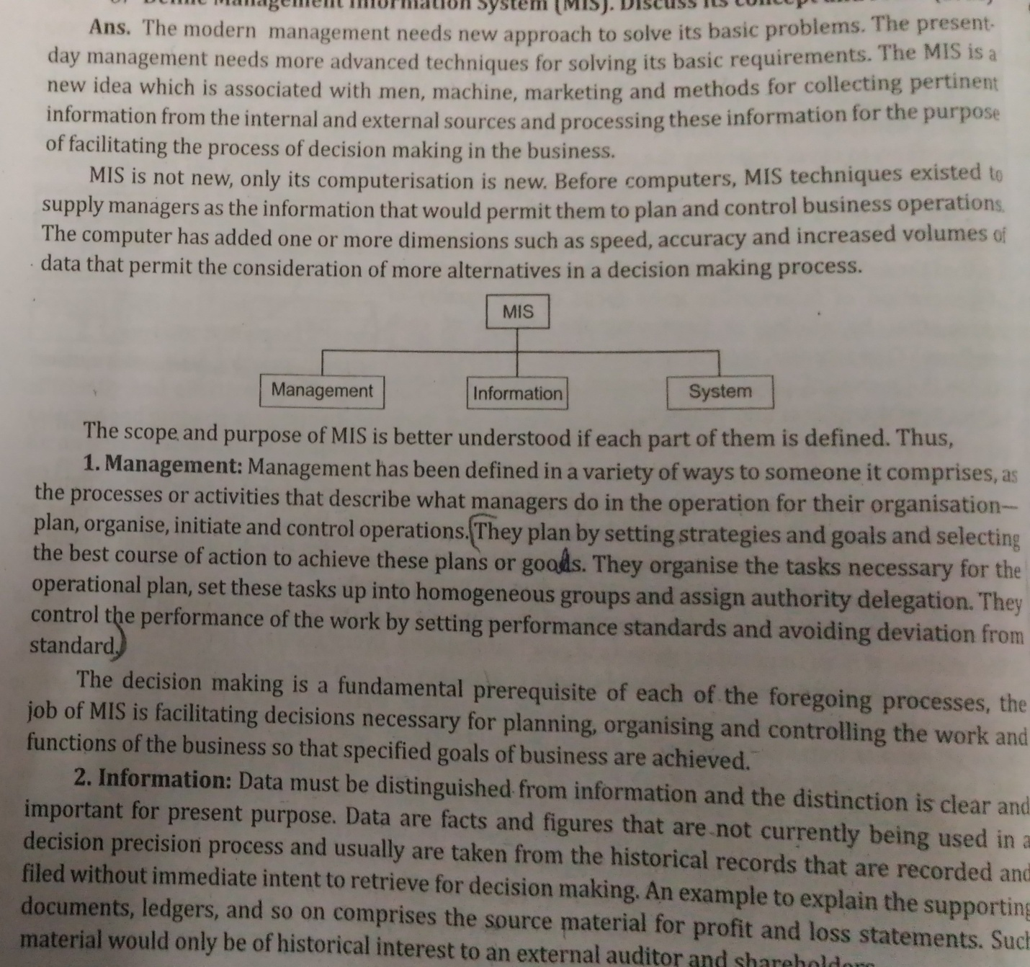

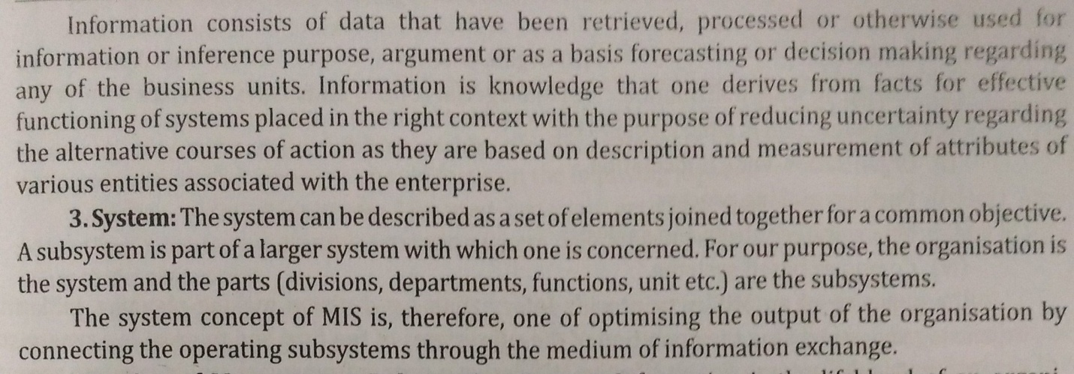

**Process of MIS**

The process of MIS starts by knowing MIS objectives. The objectives of MIS should be compatible with the company‟s objectives.

Management comprises process or activities they are as follows:-

1. Recognition of a problem and an opportunity
2. Define problem or opportunity
3. Develop alternative course of action
4. Decision
5. Implementation of plan
6. Control performance against plan

For its smooth functioning and achieving of its predetermined goals through optimal utilization of its resources like men, money, material and machines.

**MIS - A Tool for Management Process**

 The process of management requires a lot of data and information for execution of the plan. This requirement arises on account of the fact in each step of management, a variety of decisions are taken to correct the course of development. The decisions or actions are prompted due to the feedback given by the control system incorporated in the management system. The control of overall performance is made possible by way of Budget Summarizes and reports. The summary showing sales, costs, profit and return on investment throws light on the direction the organization is moving to. The exception reports identify the weaknesses tin the system of management.

 If effective management system is to be assured, it has to rest on business information. The management performance improves if the business risk and uncertainties are handled effectively. If the information provided is adequate, one can deal with these factors squarely. The information support improves the lack of knowledge, enriches experience and improves analytical abilities leading to better business judgment. So, if efficient information support is to be provided, it calls for a system with the goals of generating management information. A good MIS must furnish information to the managers to expand their knowledge base. He must know the adverse trends in business, the shortfalls and failures in the management process.

**The impact of the Management Information System**

 The impact of MIS on the functions is in its management. With a good MIS support, the management of marketing, finance, production and personnel becomes more efficient, the tracking and monitoring the functional targets becomes easy. The functional managers are informed about the progress, achievements and shortfalls in the activity and the targets. The manager is kept alert by providing certain information indicating the probable trends in the various aspects of business. This helps in forecasting and long-term perspective planning. The manager'' attention is brought to a situation which is exceptional in nature, inducing him to take an action or a decision in the matter. A disciplined information reporting system creates a structured database and a knowledge base for all the people in the organization. The information is available in such a form that it can be used straight away or by blending and analysis, saving the manager's valuable time.

 The MIS creates another impact in the organization which relates to the understanding of the business itself. The MIS begins with the definition of a data entity and its attributes. It uses a dictionary of data, entity and attributes, respectively, designed for information generation in the organization. Since all the information systems use the dictionary, there is common understanding of terms and terminology in the organization bringing clarity in the communication and a similar understanding of an event in the organization.

 The MIS calls for a systemization of the business operations for an effective system design. This leads to streamlining of the operations which complicate the system design. It improves the administration of the business by bringing a discipline in its operations everybody is required to follow and use systems and procedures. This process brings a high degree of professionalism in the business operations.

 Since the goals and objective of the MIS are the products of business goals and objectives, it helps indirectly to pull the entire organization in one direction towards the corporate goals and objectives by providing the relevant information to the people in the organization.

 A well designed system with a focus on the manager makes an impact on the managerial efficiency. The fund of information motivates an enlightened manager to use a variety of tools of the management. It helps him to resort to such exercises as experimentation and modeling. The use of computers enables him to use the tools and techniques which are impossible to use manually. The ready-made packages make this task simpler. The impact is on the managerial ability to perform. It improves the decision making ability considerably.

**Management Information System and Computer**

 Translating the real concept of the MIS into reality is technically, an infeasible proposition unless computers are used. The MIS relies its ability to store, process, retrieve and communicate with no serious limitations.

 The variety of the hardware having distinct capabilities make it possible to design the MIS for a specific situation. For example, if the organization needs a large database and very little processing, a computer system is available for such a requirement. Suppose the organization has multiple business locations at long distances and if the need is to bring the data at one place, process, and then send the information to various locations, it is possible to have a computer system with a distributed data processing capability. If the distance is too long, then the computer system can be hooked through a satellite communication system.

 The ability of the hardware to store data and process it at a very fast rate helps to deal with the data volumes, its storage and access effectively. The ability of the computer to sort and merge helps to organize the data in particular manner and process it for complex lengthy computations. Since the computer is capable of digital, graphic word, image, voice and text processing, it is exploited to generate information and present it in the form which is easy to understand for the information user.

 The software, an integral part of a computer system, further enhances the hardware capability. The software is available to handle the procedural and nonprocedural data processing. For example, if you want to use a formula to calculate a certain result, an efficient language is available to handle the situation. If you are not required to use a formula but have to resort every time to a new procedure, the nonprocedural languages are available.

 The advancement in computer and the communication technology has made the distance, speed, volume and complex computing an easy task. Hence, designing the MIS for a specific need and simultaneously designing a flexible and open system becomes possible, thereby saving a lot of drudgery of development and maintenance of the system. The concept of user friendly systems and the end user computing is possible, making information processing a personalized function. However, the application of the management principles and practices in today's complex business world is possible only when the MIS is based on a computer system support.

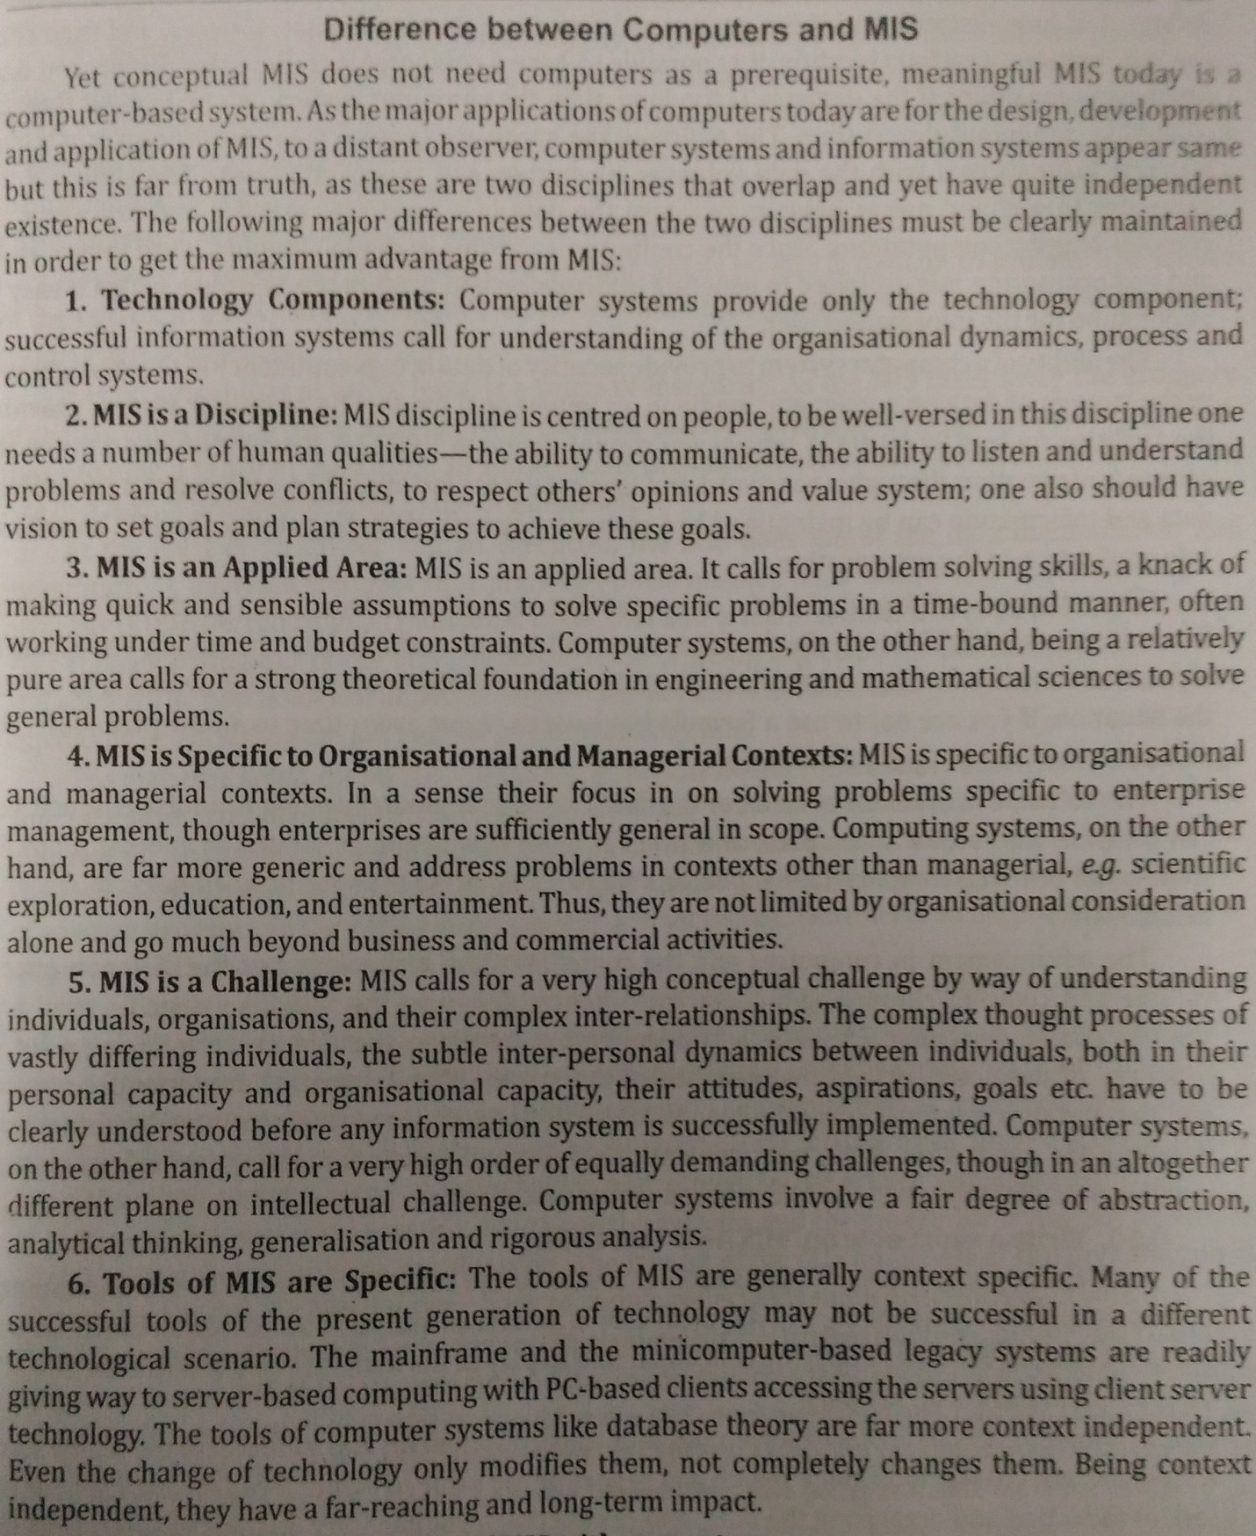

**MIS and the User**

 Every person in the Organization is a user of the MIS. The people in the organization operate at all levels in the hierarchy. A typical user is a clerk, an assistant, an officer, an executive or a manager. Each of them has a specific task and a role play in the management of business. The MIS caters to the needs of all persons.

 The main task of a clerk is to search the data, make a statement and submit it to the higher level. A clerk can use the MIS for a quick search and reporting the same to higher level. An assistant has the task of collecting and organizing the data, and conducting a rudimentary analysis of it. The MIS offers the user tools to perform these tasks. An officer has a role of integrating the data from different systems and disciplines to analyze it and make a critical comment if anything adverse is found.

 In MIS offers the methods and facilities to integrate the data and report the same in a proper format. An executive plays the role of a decision maker. He is in a position of responsibility and accountability; a position of a planner and a decision maker. He is responsible for achieving the targets and goals of the organization. The MIS provides facilities to analyze the data and offers the decision support systems to perform the task of execution. The MIS provides action-oriented information.

 The manager has a position of responsibility and accountability for the business results. His management role expands beyond his management function. The MIS provides information in a structured or unstructured format for him to react. The MIS caters to his constant changing needs of information. The user of the MIS is expected to be a rational person and the design of the MIS is based on this assumption.

 However, in reality the impact created on individuals by MIS is difficult to explain.

 The recent major technological advances in communication such as Multimedia, Imaging, Graphical User Interface (GUI) etc and the ability to access the data stored at different locations on the variety hardware of platforms would make MIS more attractive and efficient proposition. An intelligent user of information can demonstrate the ability of decision making, since his manipulative capability is considerably increased, with the information now being available on his desktop.

 Through the MIS, the information can be used as a strategic weapon to counter the threats to business, make businesses more competitive, and bring about the organizational transformation through integration. A good MIS also make an organization seamless by removing all the communication barriers.

**MIS- a support to the management**

